

**INDIVIDUAL ASSIGNMENT**

**COMP50011**

**MOBILE APP DEVELOPMENT II**

**IF21A1COM**

**HAND OUT DATE: 27th March 2023**

**HAND IN DATE: 05th June 2023**

**SAMARAKOON ARACHCHIGE ISURIKA LAKSHANI**

**CB009957**

**INSTRUCTION TO CANDIDATES**

1. **Students are advised to underpin their answers with the use of references (cited using the Harvard Referencing Style).**
2. **Late submission will be awarded zero (0) unless extenuating circumstances (EC) are upheld.**
3. **Cases of plagiarism will be penalized.**
4. **The assignment should be submitted as a softcopy:**
   1. **The softcopy of the written assignment and source code where appropriate should be on a CD in an envelope / CD cover and attached to the hardcopy.**

Table of Contents

Introduction 4

Idea outline 5

Application technology 6

Features 7

Architecture 8

Application snaps 8

Home page 9

Profile page 10

Menu page 11

Contact Us page. 12

Cart page 13

Location (map) 14

My orders page. 15

Testing 16

Lighthouse testing 16

Unit Testing - Test Cases 17

Conclusion 23

Table of figures

Figure 1 architecture 8

Figure 2 home 9

Figure 3 profile 10

Figure 4 menu 11

Figure 5 contact us 12

Figure 6 cart 13

Figure 7 location 14

Figure 8 my orders 15

Figure 9 lighthouse testing 16

Table of figures – tables

Table 1 - test cases 22

# Introduction

We have been asked to show our skills in mobile application development by building a second mobile application using an alternative approach, to show the differences in development compared to Java. So, I have picked PWA. (Progressive Web Application)

I have used React.js which is a JavaScript library, Node.js, and Express with SQLite database to develop my application.

# Idea outline

Yummy Foods is a restaurant that serves and delivers delicious fast food like pizzas, burgers, and appetizers.  
I am introducing a PWA application that can order food online using a mobile phone as well as a desktop computer. With this application, I hope to provide convenience to busy people and increase the income of the restaurant by making my application interactively and effective.

# Application technology

I have designed and implemented a Progressive Web Application using React.js, Node.js, Express, and SQLite.

* It’s a PWA application that can install on your device as a normal application.
* App-like features. (Offline mode, push notification, add to home screen)
* Short loading time.
* Good performance in poor network conditions
* Progressive and responsive.

# Features

* Geolocation – to track the customer location to deliver food.
* Dark mode – to increase usability.
* Be configured with app manifest. – to create a PWA application
* Form design – login/ register/ place order

# Architecture

# Application snaps

Figure architecture

## Home page

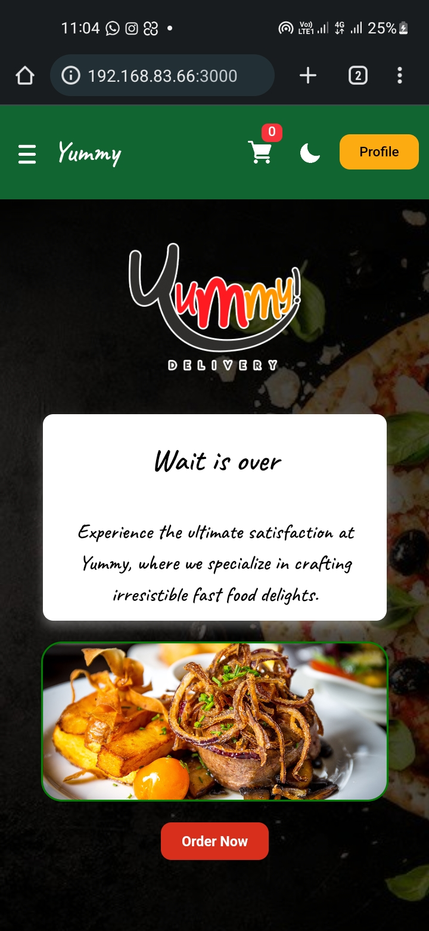

Figure home

## Profile page

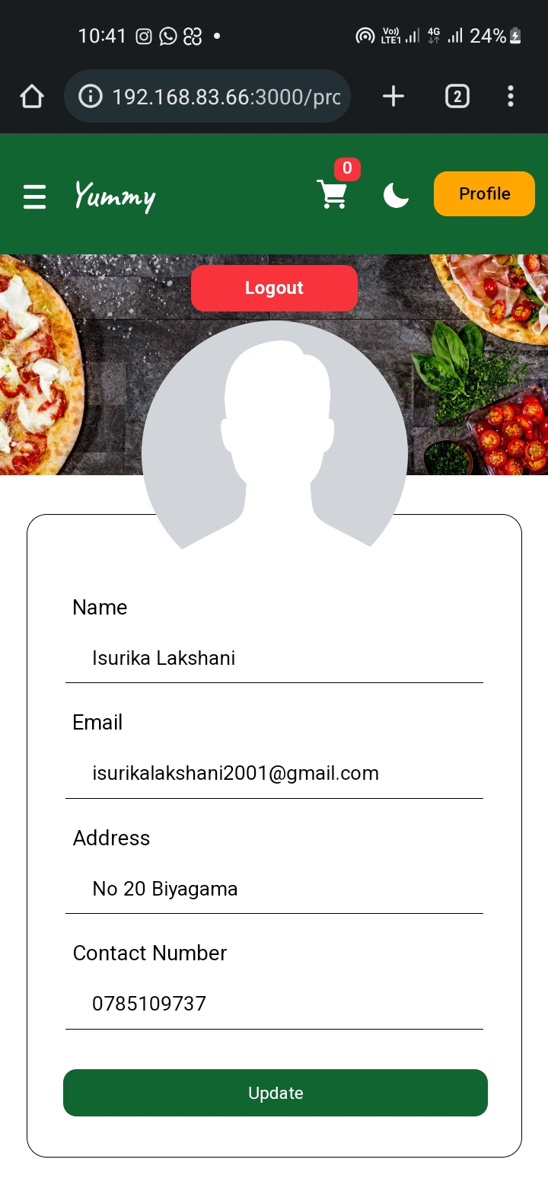

Figure profile

## Menu page

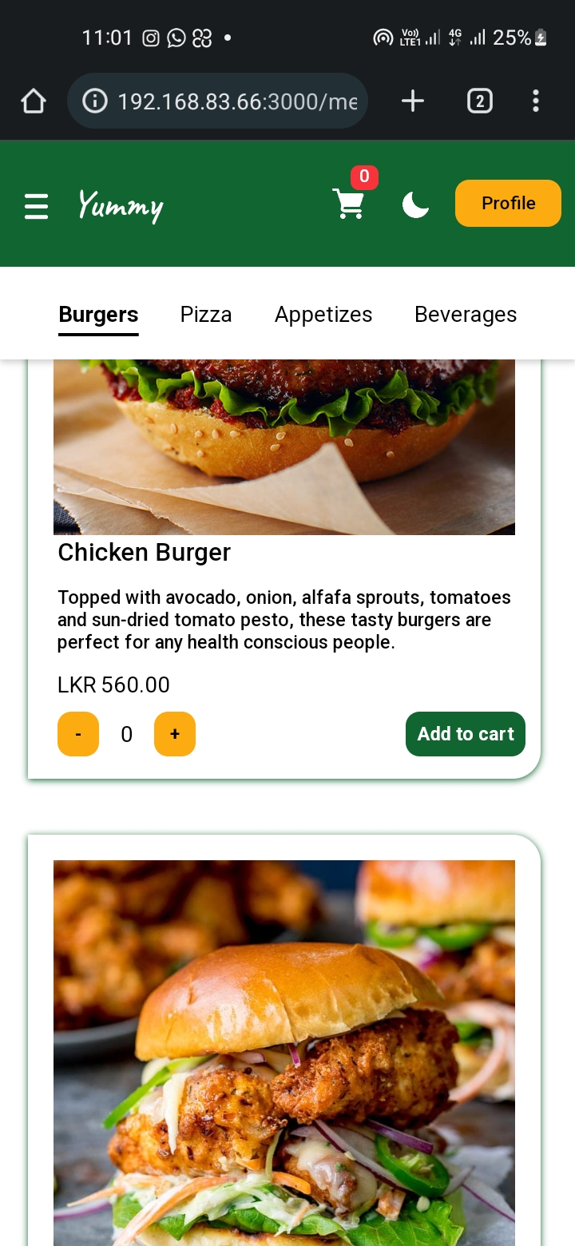

Figure menu

## Contact Us page.

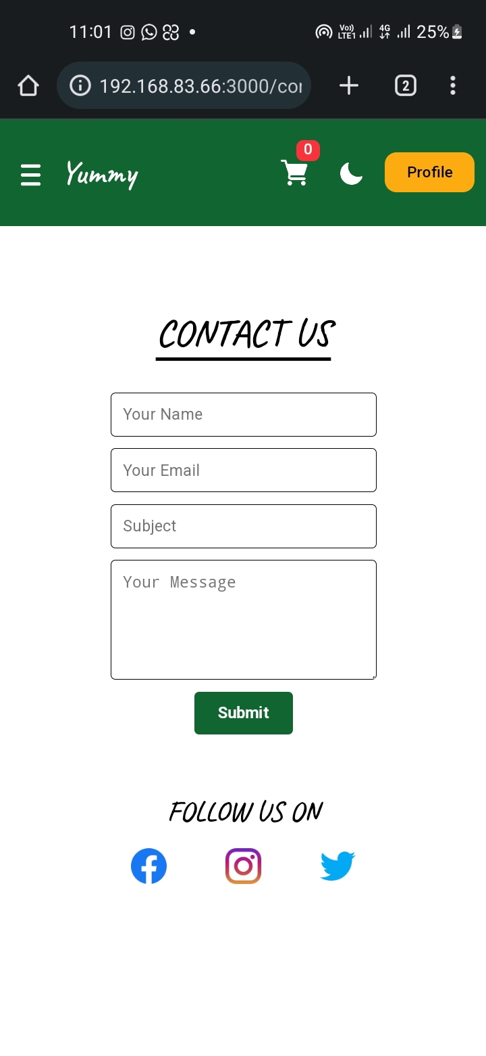

Figure contact us

## Cart page

Figure cart

## Location (map)

Figure location

## My orders page.

Figure my orders

Testing

## Lighthouse testing

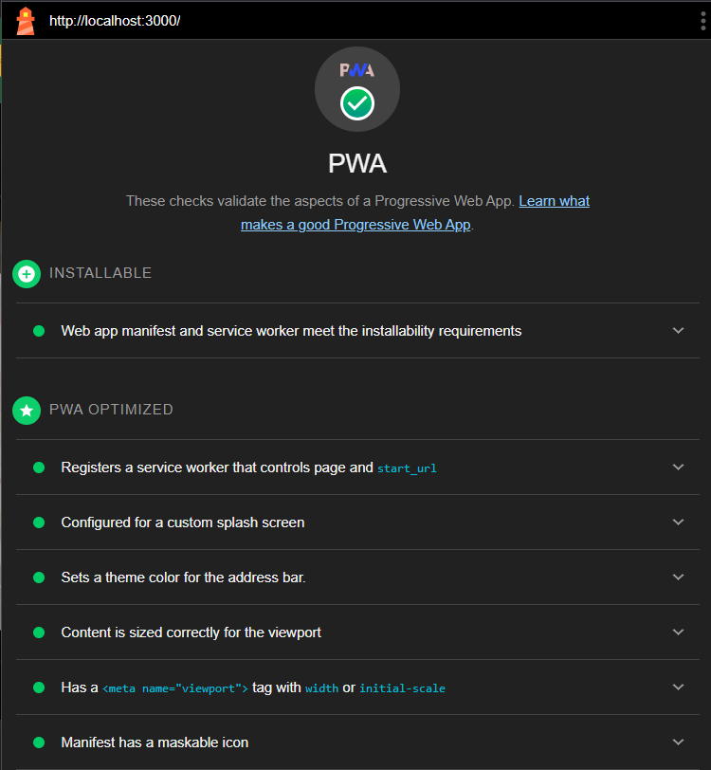

Figure lighthouse testing

## Unit Testing - Test Cases

|  |  |  |  |  |  |  |  |
| --- | --- | --- | --- | --- | --- | --- | --- |
| **Test ID** | **User** | **Test case name** | **Preconditions** | **Test scenario** | **Expected outcome** | **Actual outcome** | **Test result** |
| REG01 | customer | Verify successful register credentials | - | 1. click on the sign-up link.  2. enter customer details   * Name – Isurika * Email – [isurikalakshani2001@gmail.com](mailto:isurikalakshani2001@gmail.com) * Password – 11111 * Confirm-password - 11111   4. click the sign-up button. | The customer registers and logs into the system.  Navigate to the home page | The customer registered and logged into the system.  Navigated to the home page | pass |
| REG02 | customer | Customer registration fails due to an invalid email | - | 1. click on the sign-up link.  2. enter customer details   * Name – Nimasha * Email – [nimasha.com](mailto:nimasha@gmail.com) * Password – 11111 * Confirm-password - 11111   4. click the sign-up button. | The system displays an error message called “invalid email” | The system displayed an error message called “invalid email” | pass |
| REG03 | customer | Customer registration fails due to an invalid password | - | 1. click on the sign-up link.  2. enter customer details   * Name – Nimasha * Email – [nimasha@gmial.com](mailto:nimasha@gmial.com) * Password – 111 * Confirm-password - 111   4. click the sign-up button. | The system displays an error message called “invalid password. Password must contain at least 5 characters.” | The system displayed an error message called “invalid password. Password must contain at least 5 characters.” | pass |
| REG04 | customer | Customer registration fails due to mismatched passwords | - | 1. click on the sign-up link.  2. enter customer details   * Name – Nimasha * Email – [nimasha@gmail.com](mailto:nimasha@gmail.com) * Password – 11111 * Confirm-password - 11122   4. click the sign-up button. | The system displays an error message called “Passwords do not match.” | The system displayed an error message called “Passwords do not match.” | pass |
| REG05 | customer | Customer registration fails due to unique constraint | The provided email should be registered in the system previously. | 1. click on the sign-up link.  2. enter customer details   * Name – Nimasha * Email – [isurikalakshani2001@gmail.com](mailto:isurikalakshani2001@gmail.com) * Password – 11111 * Confirm-password - 11111   4. click the sign-up button. | The system displays an error message called “email should be unique.” | The system displayed an error message called “email should be unique.” | pass |
| LOG01 | customer | Customer login fails due to empty fields | The customer should be registered to the system. | 1. click on the sign-in link.  2. click the sign-in button. | The system displays an error message called “All fields are required.” | The system displayed an error message called “All fields are required.” | pass |
| LOG02 | customer | Customer login fails due to an invalid password | The customer should be registered to the system. | 1. click on the sign-in link.  2. enter customer details   * Email – [isurikalakshani2001@gmail.com](mailto:isurikalakshani2001@gmail.com) * Password – 22222   4. click the sign-in button. | The system displays an error message called “invalid username or password.” | The system displayed an error message called “invalid username or password.” | pass |
| LOG03 | customer | Customer registration fails due to an invalid email | The customer should be registered to the system. | 1. click on the sign-in link.  2. enter customer details   * Email – [isurikalakshani@gmail.com](mailto:isurikalakshani@gmail.com) * Password – 11111   4. click the sign-in button. | The system displays an error message called “invalid username or password.” | The system displayed an error message called “invalid username or password.” | pass |
| LOG04 | customer | Verify successful login credentials | The customer should be registered to the system. | 1. click on the sign-in link.  2. enter customer details   * Email – [isurikalakshani2001@gmail.com](mailto:isurikalakshani2001@gmail.com) * Password – 11111   4. click the sign-in button. | The customer login to the system.  Navigate to the home page | The customer logged into the system.  Navigate to the home page | pass |
| UPD01 | Customer | Profile update failed due to an invalid contact number | The customer should be logged in to the system | 1. click on the profile button  2. click the update button | The system displays an error message called “invalid contact number.” | Fields were updated. | fail |
| UPD02 | Customer | Update Profile | The customer should be logged in to the system | 1. click on the profile button  2. update required fields   * Name – Isurika Lakshani * Address – No 20 Biyagama * Contact number - 0785109735   3. click the update button | The system displays a successful message and updates the record | The system displayed a successful message and updated the record | pass |
| ATC01 | Customer | Add item to the cart fails due to zero quantity | - | 1. click on the menu tab from the main menu  2. click add to cart - Chicken burger | The system displays an error message called “Quantity cannot be 0.” | The system displayed an error message called “Quantity cannot be 0.” | pass |
| ATC02 | Customer | Add item to the cart | - | 1. click on the menu tab from the main menu  2. increase the quantity – Chicken burger   * Quantity - 1   3. click add to cart - Chicken burger | The system adds the item to the cart with the correct quantity | The system added the item to the cart with the correct quantity | pass |
| CLR01 | Customer | Clear cart | There should be at least one item in the cart | Click the clear button on the cart page | The system clears the cart | The system cleared the cart | pass |
| PLO01 | Customer | Place order fails due to an empty location | There should be at least one item in the cart | 1. insert or update the contact number - 0785109735  2. click the place order button on the cart page | The system displays an error message called “Please select your location.” | The system displayed an error message called “Please select your location.” | pass |
| PLO02 | Customer | Place order fails due to an empty contact number | There should be at least one item in the cart | 1. insert or update the contact number - NULL  2. select the location  3. click the place order button on the cart page | The system displays an error message called “Please enter your contact number.” | The system displayed an error message called “Please enter your contact number.” | pass |
| PLO03 | Customer | Place order fails due to an invalid contact number | There should be at least one item in the cart | 1. enter contact number – 047848  2. select the location  3. click the place order button on the cart page | The system displays an error message called “Please enter your contact number.” | The system displayed an error message called “Please enter your contact number.” | pass |
| PLO04 | Customer | Place order | There should be at least one item in the cart | 1. insert or update the contact number - 0785109735  2. add location by clicking on the locate me button  3. click the place order button | Place order successfully.  The system displays a successful message called “order successful.”  Navigate to my orders page | Placed order successfully.  The system displays a successful message called “order successful.”  Navigated to my orders page | pass |
| LGT01 | Customer | Logout from the system | - | Click the logout button on the profile page | The customer logout from the system.  navigates to the home page | The customer logged out of the system.  navigated to the home page | pass |
| DRK01 | Customer | Switch to the dark mode |  | Click on the dark mode icon on the navigation bar | The system switches to the dark mode | The system switched to the dark mode | pass |
| **Corrections** | | | | | | | |
| UPD01 | Customer | Profile update failed due to an invalid contact number | The customer should be logged in to the system | 1. click on the profile button  2. click the update button | The system displays an error message called “invalid contact number.” | The system displayed an error message called “invalid contact number.” | pass |

Table 1 - test cases

# Conclusion

In conclusion, the purpose of this assignment is to design and build a mobile application to showcase my mobile app development skills. To accomplish this task, I have used Visual Studio Code editor with React.js which is a JavaScript library to develop the frontend, node.js, and express to the backend with SQLite database to implement this application. I have used all necessary input validations according to the scenario. And I have done all possible unit testing with PWA lighthouse testing for this application.